Wireless Marvels / Netfeed Technologies
Visual Intelligence Portal (VIP)
SmartList with SoftStops™

Quick Start Guide

Like any new software product, when you first encounter the SmartList you may be confused and lost because you don’t know how to operate its features and functions. There are many built in capabilities that may be enabled and disabled and you may change the entire appearance of the display if desired. The full manual at the URL http://www.wirelessmarvels.com/~vip describes the control and operation of all features. This Quick Start Guide just points out the basic essentials to establish a single portfolio with SoftStop® (trailing stop) functionality and/or high/low alerts.

First Encounter with SmartList

This very first time you log into the SmartList you are presented with a display screen containing 3 charts along the top, then a Quick Buttons Control Bar and a row of column headings. This is followed by rows of real-time stock market financial data. The Control Bar and default column headings appear as follows:

The Quick Buttons Control Bar is used to rapidly access functions such as adding and deleting securities, setting preferences, adding portfolios, and more. You can learn the function of each button by placing the cursor over the button and waiting a few seconds for the name of the button to appear. The second line contains the column headings under which that specific security data is shown for each security in the portfolio.

Setting Your Preferences

There are several settings under your control. We’ll set up the most import settings for SmartLists with SoftStops at this point. Go to the Preferences pop up window by pressing that button on the Quick Control Bar.

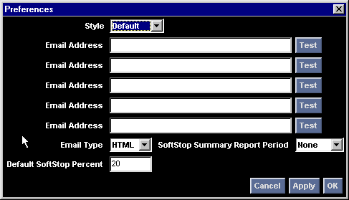
The Email address of where to send SoftStop Alert notices and reports should be listed. It is suggested that at least two different Email addresses are specified, given the importance of Alert messages. The first address might be your standard Email address while the second Email address might be that of your wireless device. The Email/Text drop down is used to select if HTML or Text Only formatting is accepted at the specified Email address. After new addresses are entered, press the Test button next to the address in order to insure that a test message is properly received. The SoftStop Summary Reporting option can be set from this window to None, Daily or Weekly – providing a summary report on trading and the current value of the SoftStop point. Finally, the default SoftStop Percentage may be changed from 20% to another value. Regardless of the default setting, the user may always override the SoftStop value for a particular security. Click OK to close this window.

Setting Up Your Portfolio

The service initially displays a portfolio of many very active large cap businesses. For each of these securities, the data displayed is Symbol, Security Name, Current Price, Net Change from yesterdays close, the percent change from yesterday’s close, the volume of the last trade, yesterdays closing price, today’s opening price, today’s high and low, and the total volume traded today. We will change these columns to ones that are more appropriate for monitoring SoftStops.

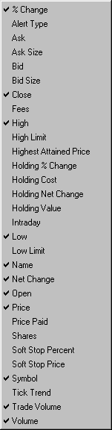

Move the cursor over any of the column headings such as Volume, and right click to obtain a list of all possible columns that may be displayed. You will see that those columns currently selected have a checkmark. You can make one change at a time by pointing at a line of the list that is not checked (which causes it to be checked and added), or at a line that is checked (which causes it to be unchecked and removed). Add SoftStop Price, Price Paid, and remove Trade Volume. You can change the width of any column by moving the cursor to the left or right edge of the column next to the heading name and dragging it to the desired width while holding down the left mouse button. You can even change the order of the columns by pointing the cursor in the middle of the column heading name and dragging the column while holding down the left mouse button. And you can even change the sorting of the data on the display, by left clicking on a column heading. Click on the Symbols column to sort the portfolio in alphabetic order.

Adding a Symbol and Setting an Alert

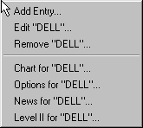
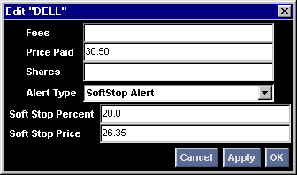
To add a symbol to the portfolio, point to any cell in the portfolio (not the heading lines) and right click. Point to the “Add Entry” selection and a pop up window will appear. Enter the ticker symbol of the security to be monitored and click OK to put it into the portfolio. To add an alert or SoftStop to this new security, point to any cell in the row of data associated with that security and right click. Select the “Edit <symbol>” selection and another pop up window will appear. You may set the Alert Type to SoftStop or Limit Alert. Let’s try SoftStop first by selecting that option for the symbol you just added. Notice that the default SoftStop percentage set in your preferences appears. In addition, if pricing data has already appeared against this security an initial SoftStop price has been set according to the current price and the percentage. You may override the percentage directly on this screen or may override the SoftStop price. If the SoftStop price is overridden, the SoftStop percentage is recalculated for this security only and is redisplayed. The price paid should be entered so that you can quickly see your position on the portfolio display. Click OK to close this window.

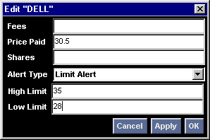
To set a High/Low limit alert for a security, you follow the same steps as described above for SoftStops, except that you select Limit Alert as the Alert Type. Set the high and low value at which you wish to be alerted. When the price goes above the high or below the low, the ticker symbol will change to Green or Red respectively.

To remove a security from the portfolio, point the cursor to any cell of data associated with that security and right click. Point to the “Remove <symbol>” entry to remove that symbol from the portfolio.
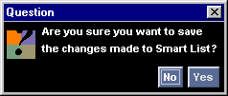
When you shut down the SmartList by closing its window, you are given the option of saving all changes you made to the portfolio during the day. As another option, you can click on the Floppy Disk looking symbol on the Quick Control Bar, and changes will be saved immediately.

You are now ready to modify the portfolio on the screen by removing those securities you do not wish to view and adding those of interest to you.

Viewing other Security Details

To view additional detailed information regarding a particular security point the cursor to the ticker symbol and left click.

